**Lesson 07 Demo 01**

**Comparing Traditional and Generative AI-based   
Test Case ​Creation**

**Objective:** To evaluate the effectiveness of traditional manual versus Generative AI-based test case creation methods for the Facebook login functionality

**Tools required:** MS-Excel, Microsoft Copilot

**Prerequisites:** Basic knowledge and understanding of writing test case scenarios manually

Steps to be followed:

1. Write test cases manually in MS Excel or Google Sheets
2. Generate the test cases using Microsoft Copilot

**Note:** Please be advised that the GenAI tools used in this demo may produce varied outputs even when presented with similar prompts.

**Step 1:** **Write test cases manually in MS Excel or Google Sheets**

* 1. Open MS Excel or Google Sheets

**Note:** You may use Google Sheets as an alternative for writing test cases.

* 1. Write the test cases for verifying the functionality of the Facebook login page as shown in the screenshot below:

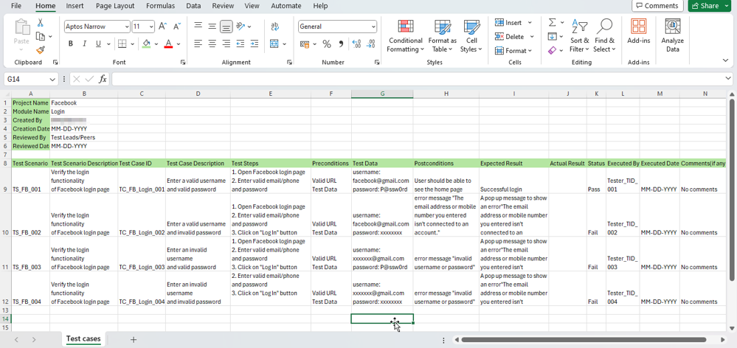

**Step 2:** **Generate the test cases using Microsoft Copilot**

* 1. Open Google Chrome, enter **microsoft copilot** in the URL box, and click Enter

* 1. Click on the first link as shown in the screenshot below:

The Microsoft Copilot homepage opens as shown below:

* 1. Click on the **Sign in** button

* 1. Select **Sign in with a work or school account**

* 1. Select the desired account

* 1. Enter the password and click on the **Sign in** button

You are successfully signed in to the Microsoft Copilot as shown below:

* 1. Add the following prompt in the **Ask me anything…** box as shown in the screenshot below:  
     **Your task is to create a detailed set of test cases for evaluating the functionality of the Facebook login page. The project name is Facebook, and it focuses on the login module. Your prompt should include fields such as project name, module name, created by, creation date, reviewed by, and review date. Outline the structure of the test cases, encompassing both positive and negative scenarios to cover various login situations, including successful logins, invalid credentials, and error message handling. Each test case should adhere to a structured format, including test scenario, test case ID, description, steps, preconditions, test data, postconditions, expected and actual results, status, executed by, execution date, and any additional comments. Aim for clarity and detail in your documentation to ensure thorough testing of the Facebook login page.**  
       
     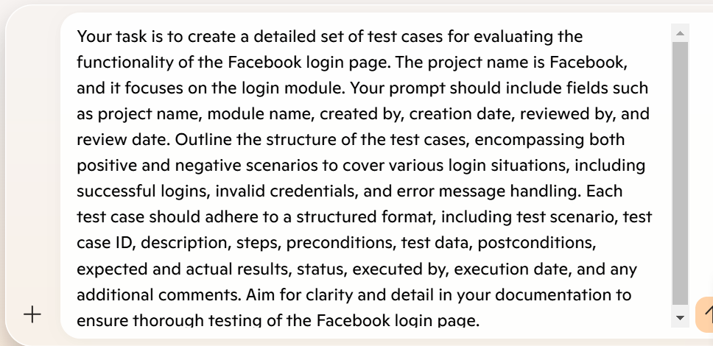
  2. Click on the **Submit** button

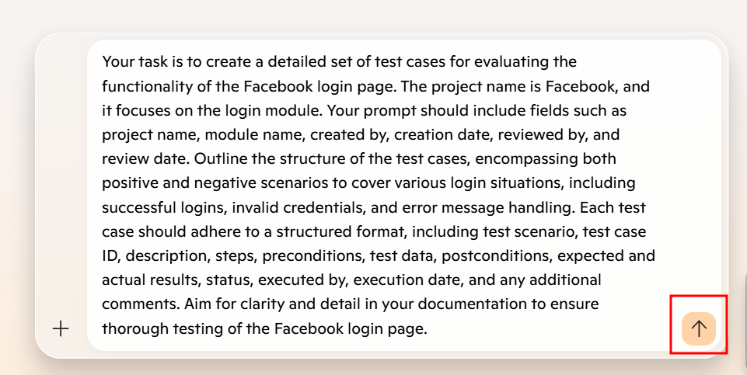

Microsoft Copilot starts generating the test case based on the prompt given.

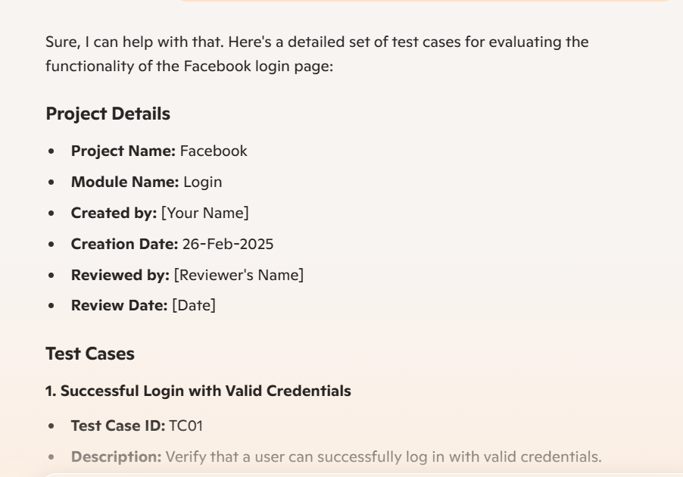

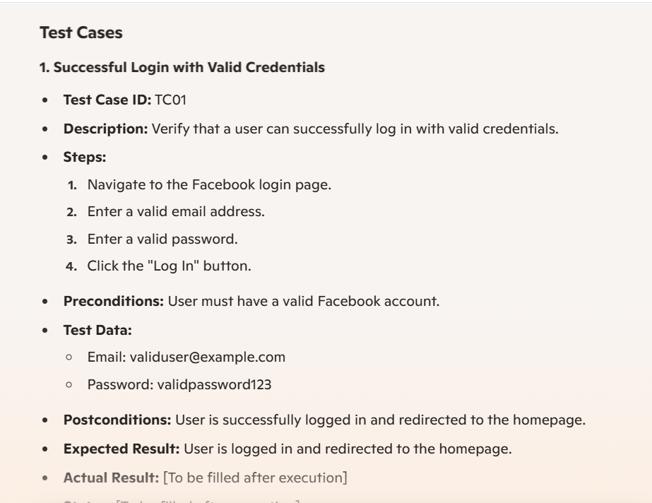

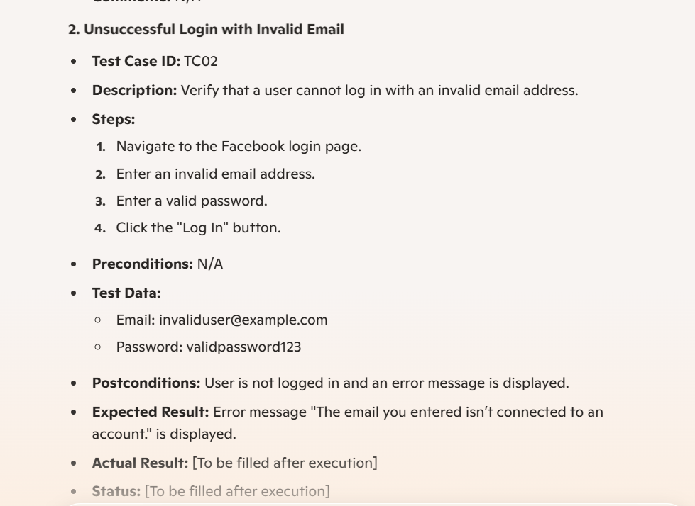

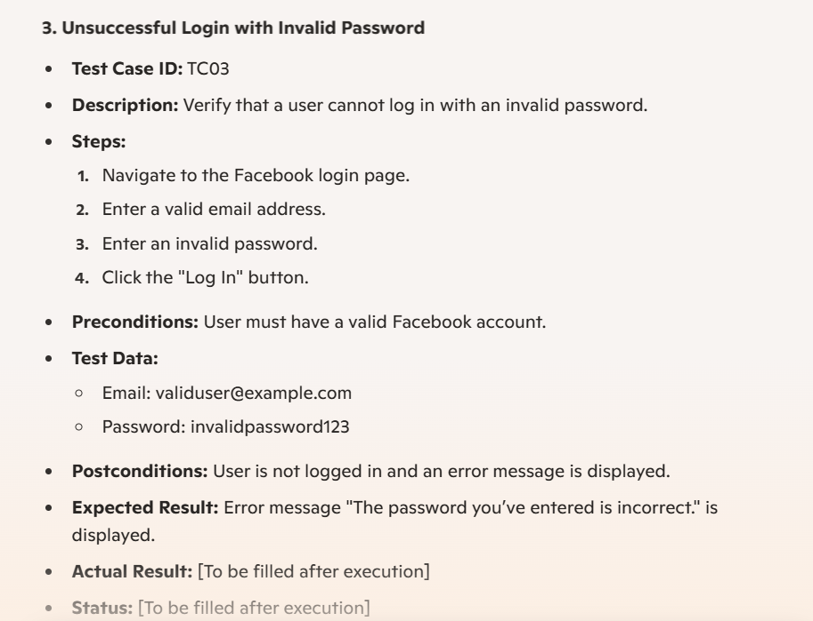

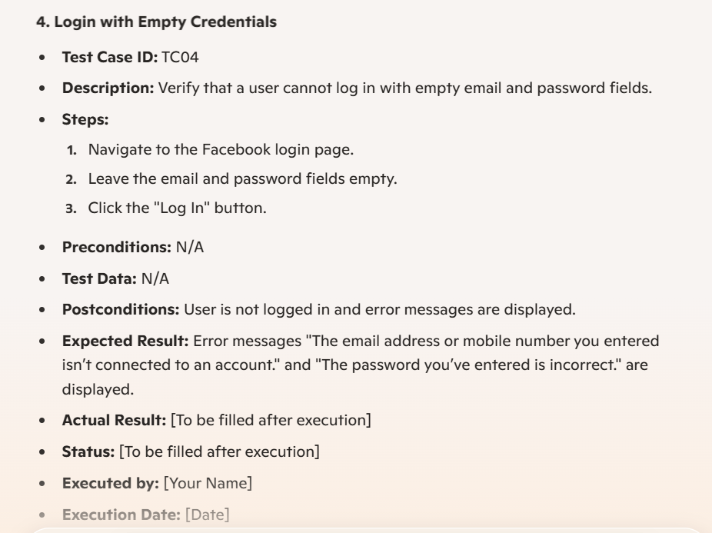

* 1. Add the following prompt to change the representation format to CSV:  
     **Add the above response in CSV format**

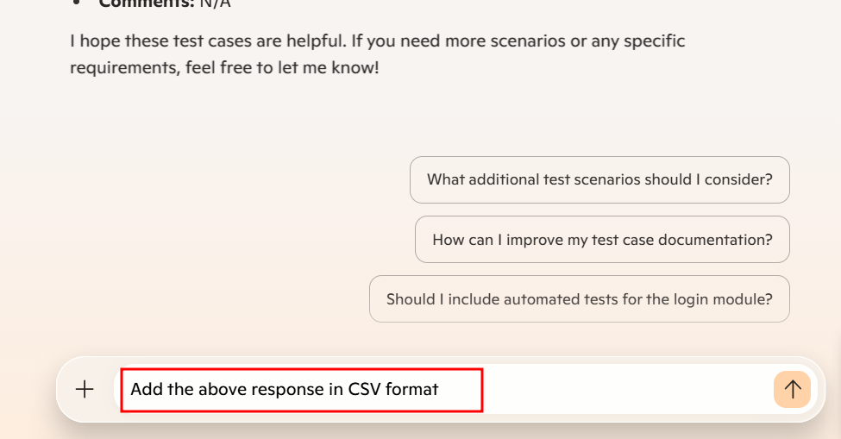

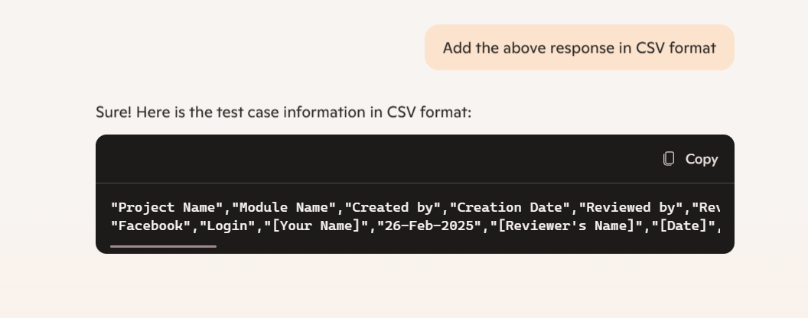

Microsoft Copilot generates the response as shown below:

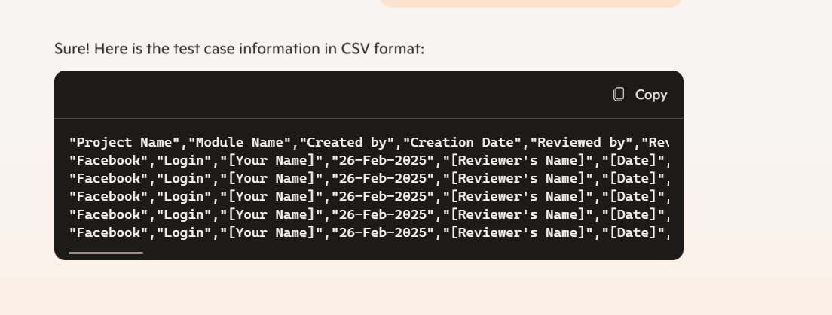

By following these steps, you have successfully evaluated the effectiveness of traditional manual methods versus Generative AI-based test case creation for the Facebook login functionality, enhancing software testing efficiency.